**Q9)** I defined x[n] and h[n] vectors and convolved them as seen in **Figure 1**.

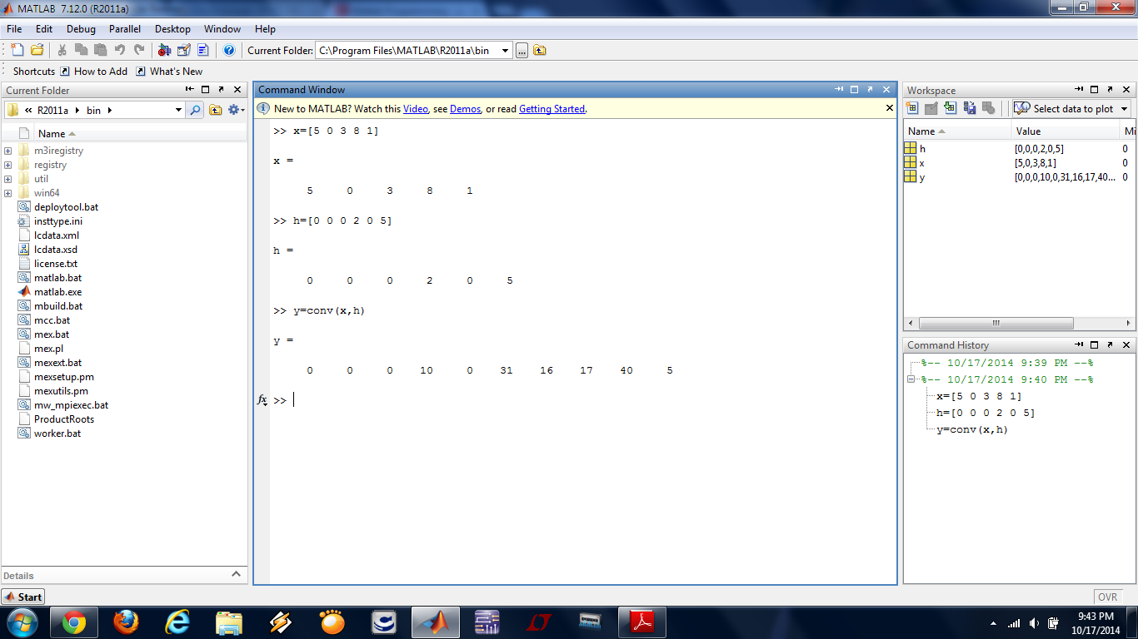

**Figure 1**

The corresponding graphs of x[n], h[n] and y[n] are shown in **Figure 2**, **Figure 3** and **Figure 4**, respectively.

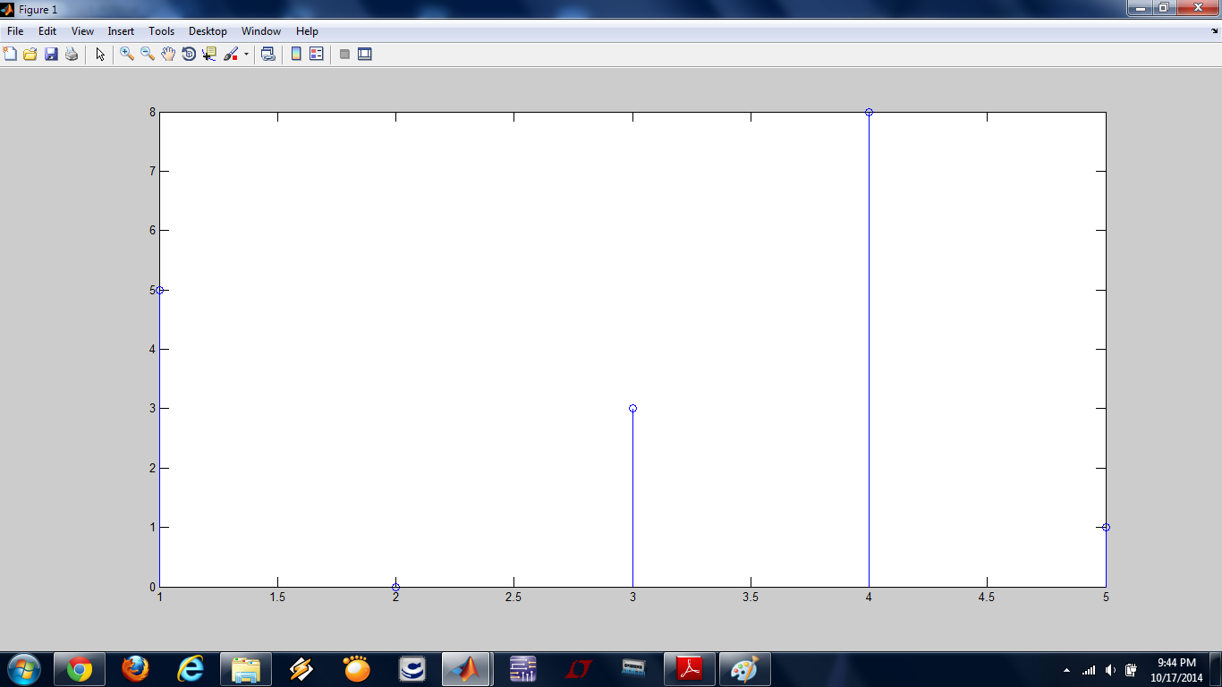

**Figure 2**

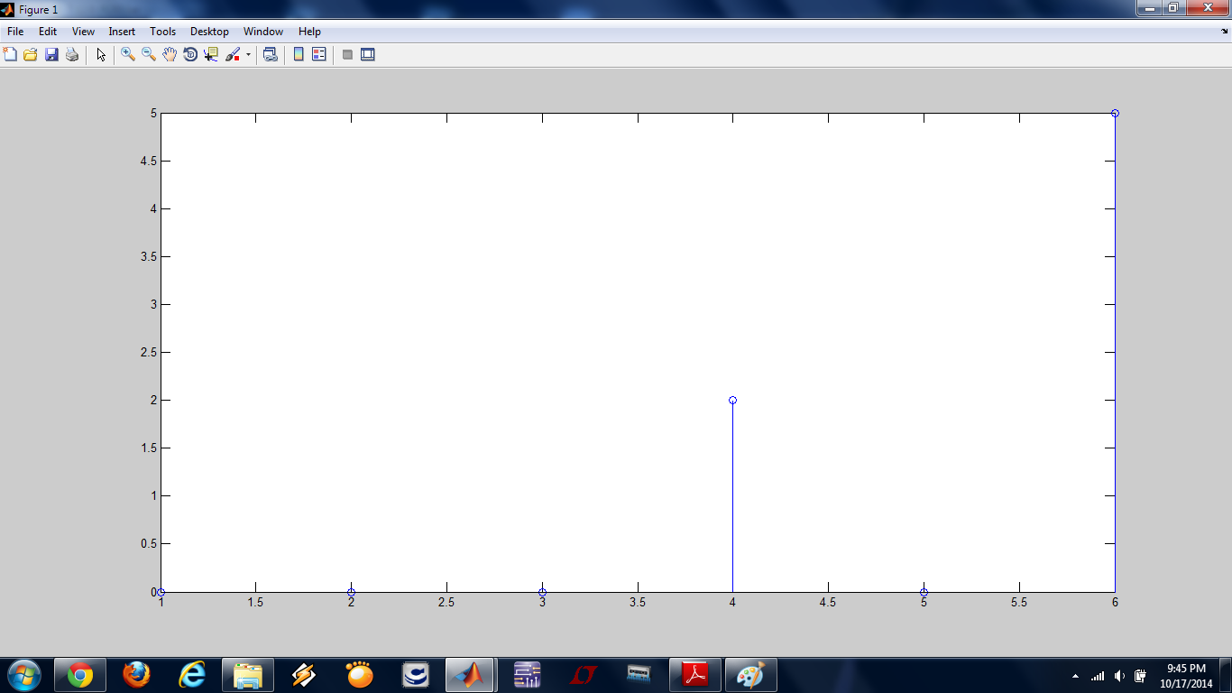

**Figure 3**

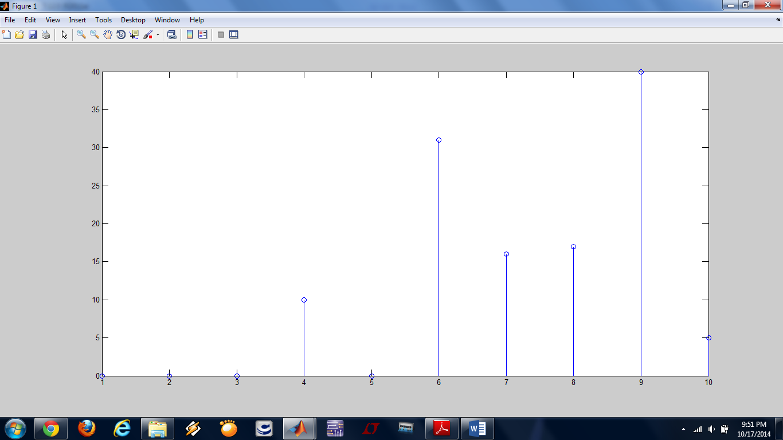

**Figure 4**

The plot of y[n] is not the one I was expecting because indices in MATLAB starts from 1. However, it does the calculations as if they were starting from 0 as usual. Therefore, **Figure 4** is wrong. It could only be fixed if one shifts the graphs above by 1 unit to the left.

**Q10)**

**a)** I defined a 3rd order polynomial with the coefficients of [3 1 2 5] and defined a 5th order polynomial with the coefficients of [5 -1 4 2 3 -3]. Then, I convolved them in order to find the coefficients of the 8th order polynomial when the two polynomials mentioned above are multiplied as in **Figure 5**.

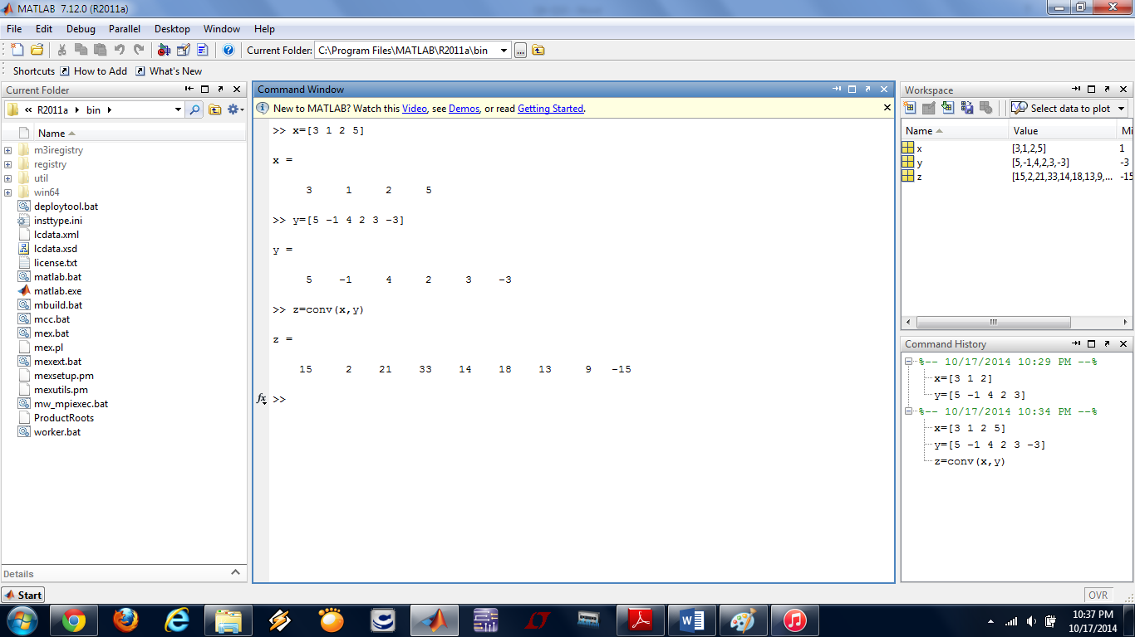

**Figure 5**

I found that the coefficients of the resultant polynomial are [15 2 21 33 14 18 13 9 -15]. Therefore, I can say that;

*(3a3+a2+2a+5) (5a5-a4+4a3+2a2+3a-3) = 15a8+2a7+21a6+33a5+14a4+18a3+13a2+9a-15*

**c)** The calculations of finding the impulse response are shown on the hand-written pages. I found a solution after some calculations and drew the corresponding impulse response. Then, I defined the vectors on MATLAB and used “deconv” command of it in order to verify my result as seen in **Figure 6**.

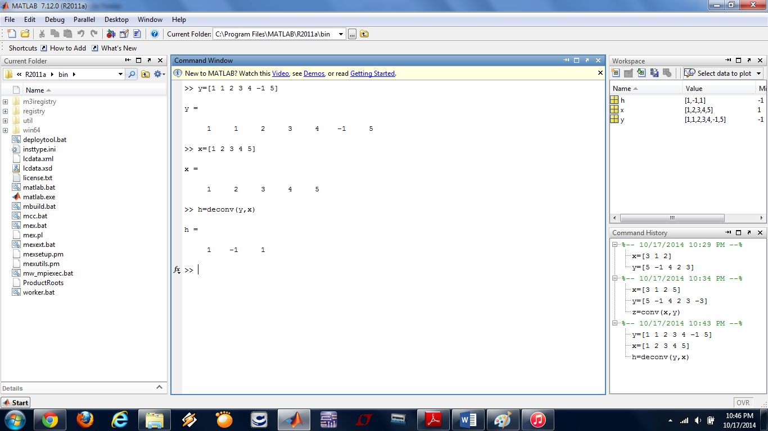

**Figure 6**

The corresponding graphs of y[n], x[n] and h[n] are shown in **Figure 7**, **Figure 8** and **Figure 9**, respectively.

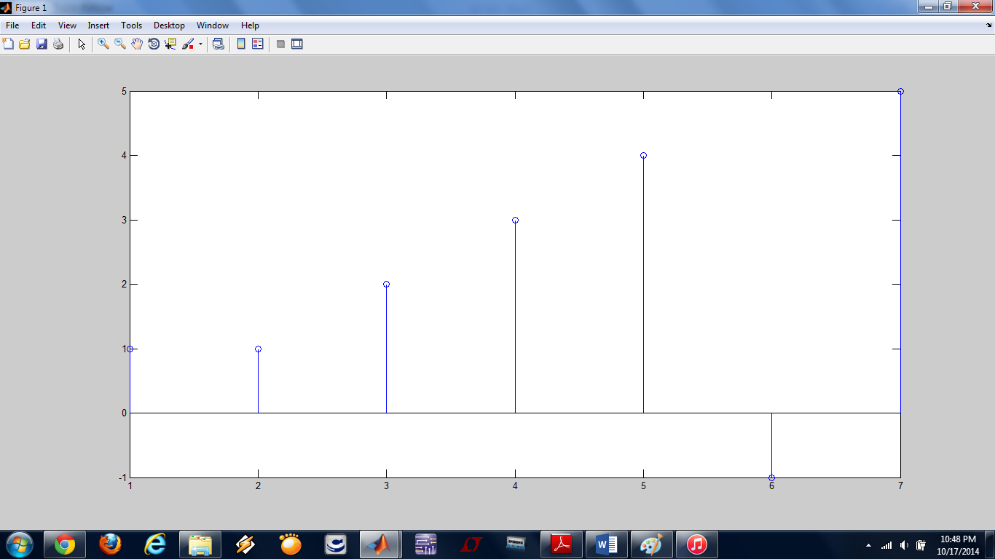

**Figure 7**

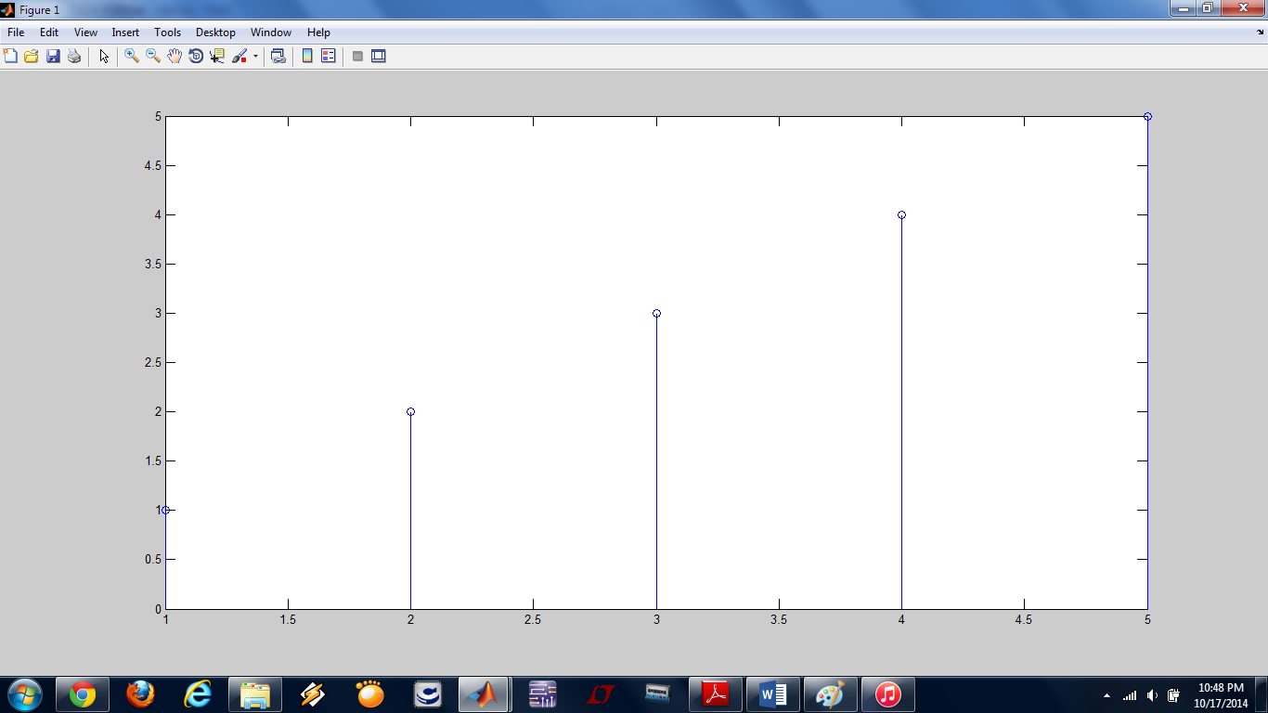

**Figure 8**

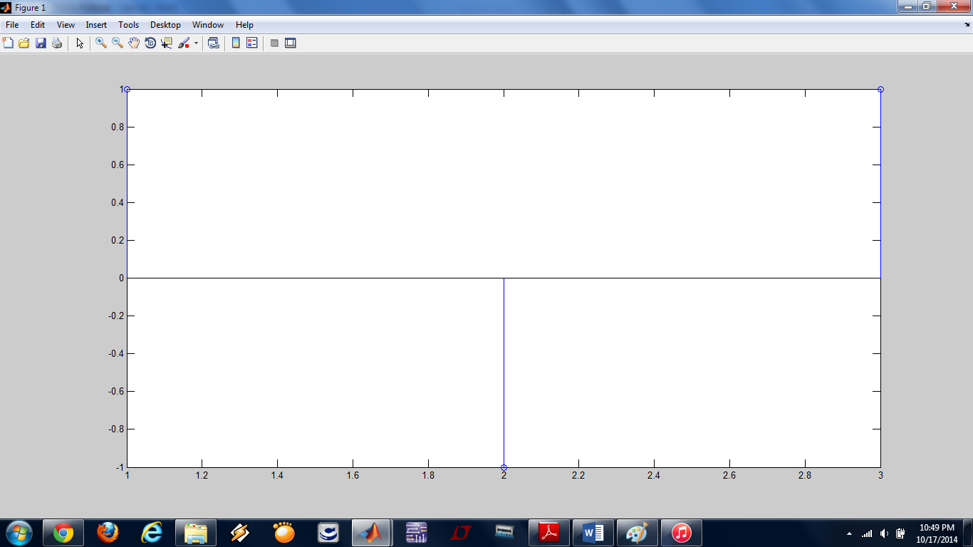

**Figure 9**

As I mentioned above, we should shift the graphs by 1 unit to the left in order to see the real and correct results.

**d)** I modified the vector y[n] in the part-c and used “deconv” command again in order to obtain the impulse response as seen in **Figure 10**.

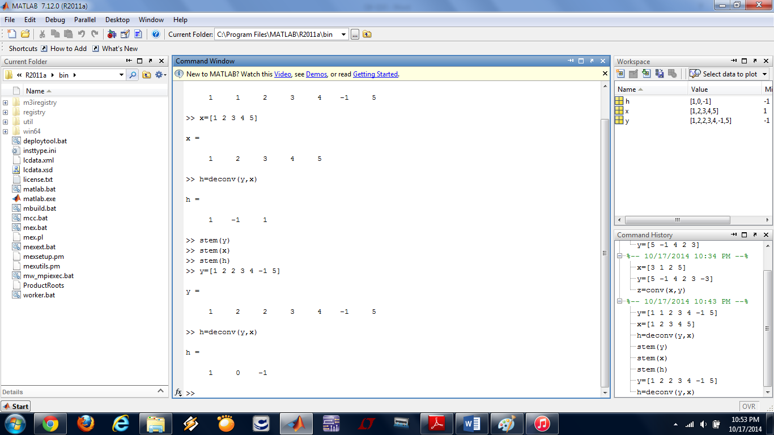

**Figure 10**

I saw that the corresponding impulse response became as [1 0 -1] as shown in **Figure 11**.

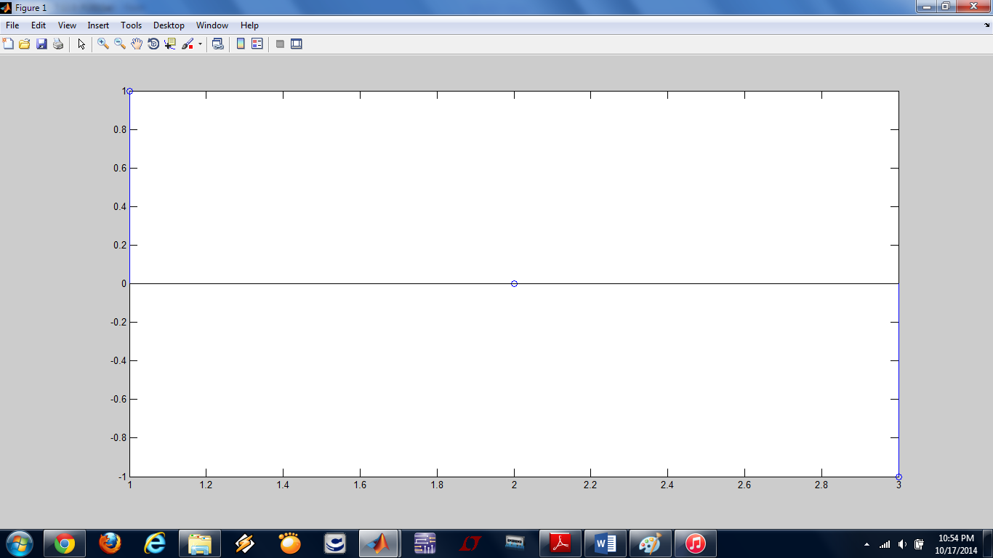

**Figure 11**

This result implies that if we want to change only one index of the output vector, we have to change more than one index of the corresponding impulse response.